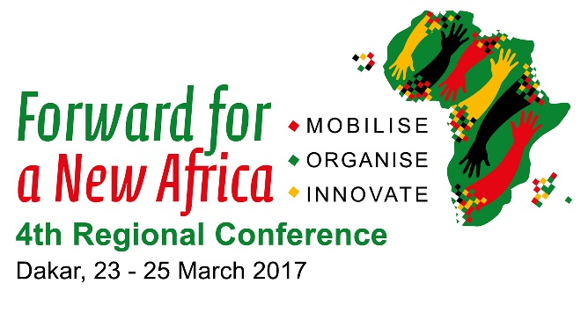

UNI Global Union and UNI Africa: Declaration Against Slavery

UNI Global Union and UNI Africa are committed to the fight against modern slavery, forced labour, human trafficking and child labour, with the aim of achieving Target 8.7 of the United Nation’s 2030 Sustainable Development (SDGs).

Under Target 8.7 world leaders vowed to: “Take immediate and effective measures to eradicate forced labour, end modern slavery and human trafficking and secure the prohibition and elimination of the worst forms of child labour, including recruitment and use of child soldiers, and by 2025 end child labour in all its forms”.

A delegation from UNI Global Union and UNI Africa is taking the opportunity of its presence in Dakar, Senegal at the 4th UNI Africa Conference to travel to Gorée Island off the most Western point of Africa, and visit the ‘House of Slaves’ with its ‘Door of No Return`, a memorial to the Atlantic slave trade. UNI will unveil a plaque to underscore its commitment to not letting the human tragedy of the African slavery be forgotten.

The plaque will include a quote from Nelson Mandela: “For to be free is not merely to cast off one’s chains, but to live in a way that respects and enhances the freedom of others.”

The ceremony will also be a moment to recognise that modern slavery is still prevalent across the world in its many odious forms and that the international must continue to take a strong stand. According to recent figures from the International Labour Organisation (ILO):

• Almost 21 million people are victims of forced labour – 11.4 million women and girls and 9.5 million men and boys.
• Almost 19 million victims are exploited by private individuals or enterprises and over 2 million by the state or rebel groups.
• Of those exploited by individuals or enterprises, 4.5 million are victims of forced sexual exploitation.
• Forced labour in the private economy generates US$ 150 billion in illegal profits per year.
• Domestic work, agriculture, construction, manufacturing and entertainment are among the sectors most concerned.
• Migrant workers and indigenous people are particularly vulnerable to forced labour, especially through so-called ‘labour brokers’ who exploit workers

UNI Global Union General Secretary and co-chair of the ILO’s child labour platform Philip Jennings has called for global business to join efforts to eliminate child labour from supply chains. "We will never give up on this endeavour until we have eliminated child labour from this planet".

Jennings said there were “168 million reasons not give up on this goal of eradicating child labour”, referring to the 168 million children working in agriculture, manufacturing, mining and other sectors, in global supply chains. At least half of the total child labourers are in hazardous work.

UNI welcomes the announcement made by the ILO, the IOM, and the Walk Free Foundation earlier this month to work together to research the scale of modern slavery around the world, in order to be able to create a new global strategy to combat it. UNI and the international union movement supports this initiative.

Despite the progress made towards eradicating slavery and racism around the world, the international trade union movement must nevertheless be at the forefront of the work in quantifying this phenomenon and working to fight it. It is in this capacity that the African trade unionists gathered at the UNI Africa Regional Conference in Dakar will not only mark their indignation to both past and present slavery by the ceremony in Gorée Island but also by welcoming Tunisian Nobel Peace Prize winner and former UGTT General Secretary Houcine Abassi. Mr Abassi said, "Today we are greatly in need of dialogue among different civilizations and a peaceful coexistence with respect to diversity and difference. Also we must fight against all forms of discrimination based on race, gender or culture, particularly in the workplace.” Mr Abassi will declare UNI and the rest of the international union movement’s determination to combat slavery and racism in any form, particularly in the workplace, and to implement a major trade union program to preserve solidarity among workers.

This Declaration against Slavery, will be taken from the UNI Africa Conference to the heart of the UNI Global Union World Congress in Liverpool next year, where it will inform a discussion CNN panel on Modern Slavery, planned to be held in conjunction with the International Slavery Museum in Liverpool.

