INVITATION TO TENDER

ANIMATOR OF PROJECT ACTIVITIES

European Sectoral Council COMMERCE for Employment and Skills: Launch and first year of activities & initiatives

BUDGET HEADING 04.04.01.01: Mutual learning in the field of skills and employment - EU Sector Skills Councils - Restructuring
Call for proposals 2012 VP/2012/009
Priority 3.2.B Sector Skills Councils – Project to be submitted in relation to the functioning of a EU Council on Employment and Skills.

- Background
The project linked with the present call for tenders follows a series of actions carried out by the applicant, in cooperation with UNI Europa, sectoral European Social partner, in the direction of the creation and functioning of a COMMERCE Sector council on Employment and skills.

In particular, trough a first project, It has been possible to identify, at European level, several so called “Observatories” or national skills councils, in any case organizations that were active at local or national level, in the field of Employment and Skills in the Commerce sector. This project has allowed the social partners to take direct contact with over 15 observatories.

A second project had the final aim of developing and launching the European COMMERCE Skills Council. All results and background knowledge generated has been exploited until this point in order to get to the final objective, which is represented by the official launching of the Council at the final conference that took place on December 5th 2012. In order to do this, the experiences carried out in the previous projects have been taken as a basis for the development of a suitable structure enabled and enforced by state of the art ICT technologies. This second project led to the completion of the following objectives:

- Establish a European network of COMMERCE observatories that exist or are emerging and, in each of them, identify organisational structure, best practices and reference personnel,
- Identification, provision, sharing and exchange of pertinent information available in these organisations;
- Establishment and development, within the European Commerce Skills Council, of cooperation framework among these observatories, and betwwen the network of observatories and the Social Partners
- Precise definition of the mission, organisational and governance structure of the COMMERCE European Skills Council
- Official creation and launching of a European sectoral council,
On the basis of the mapping and of the information analysed, European Commerce Social partners and some of the observatories identified and met has assessed during a workshop held in September 13th 2012 the feasibility of setting-up an EU sector council. The decision led to a positive result. By the final conference, held on Dec 5th 2012 a Council statute have been prepared, containing proposals concerning the composition of the future EU council, roles and responsibilities of each member, governance structure, eventual legal form. Moreover, the conference has been the occasion for the definition of a work programme (started already in the framework of project carried out in 2012) and business plan. The following precise information are therefore available:
- Structure and governance of the Council
- Interaction analysis between the Council and the established network of observatories
- Sectoral council mission, governance, operative internal structure, activities and functionalities.
Other types of potential actions to be developed by the EU sector council have been identified during the execution of the following project, as for example:
- Intensive information dissemination, through the exploitation of the Web Portal realized for the implementation of the network
- Involvement of national bodies (Ministries) in specific activities

- Purpose of the Contract
Given the background description as described above, the main objective of the present project is to launch and conduct the first year of activities of the European Sectoral Council for Employment and Skills for the Commerce Sector. The Workprogramme of the council will be based on 4 pillars:
- Information exchange
- Updated sectoral knowledge
- Direct interaction with the reference market
- Intense communication
Specific actions will be implemented in order to construct and maintain the above mentioned pillars, such as Researches and reports, Studies and Analyses, Meetings, Conferences.

- Tasks to be performed by the Contractor
The project activities will be organised as in the following GANNT diagram:
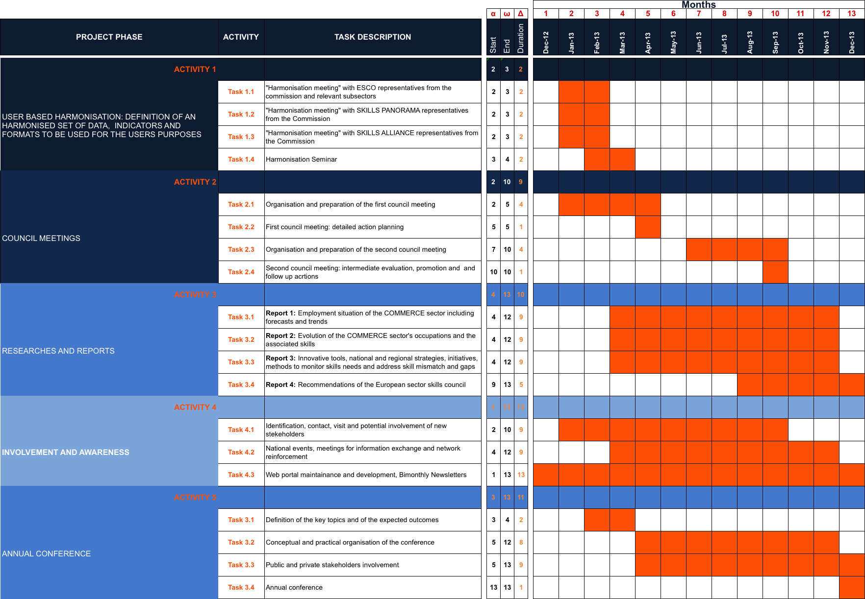
The kick off meeting of the project is expected to take place in January 2014. At the final conference the European Social Partners and the established network of observatories active in the COMMERCE sector signed a formal commitment for the implementation of the European Skills council on commerce, supported by a Web Portal specifically designed for the purpose.
The work for the 2014 project is organised in 5 different project Phases:
Project phase 1: user based harmonisation
Project phase 2: council meetings
Project phase 3: researches and reports
Project phase 4: involvement and awareness
Project phase 5: annual conference
The following paragraph describes the description of the tasks to be performed by the contractor in each project phase.

- Description of tasks
Each Project Phase is subdivided in specific activities. The detailed description of the project work plan is as follows:

Project Phase 1: User based harmonisation
Task 1.1: "Harmonisation meeting" ESCO
Task 1.2: "Harmonisation meeting" SKILLS PANORAMA
Task 1.3: "Harmonisation meeting" with SKILLS ALLIANCE
Task 1.4: Harmonisation Seminar

Tasks to be performed: produce relevant materials for discussion, cooperate in the organisation of the meetings, prepare reports, implement follow up actions

Project Phase 2: council meeting
ACT 2.1: Organization and preparation of the first council meeting
ACT 2.2: First council meeting: detailed action planning
ACT 2.3: Organization and preparation of the second council meeting
ACT 2.4: Second council meeting: intermediate evaluation, promotion and follow up actions
Tasks to be performed: produce relevant materials for discussion, cooperate in the organisation of the meetings, prepare reports, implement follow up actions

Project Phase 3: Researches and Reports
- REPORT n° 1: Employment situation of the COMMERCE sector including forecasts and trends
- REPORT n° 2: Evolution of the COMMERCE sector's occupations and the associated skills
- REPORT n° 3: Innovative tools, national and regional strategies, initiatives, methods to monitor skills needs and address skill mismatch and gaps
- REPORT n° 4: Recommendations of the European sector skills council
Tasks to be performed: coordination and control of the preparation and presentation of reports. Content and template definition, interaction with observatories and social partners.

Project Phase 4: Involvement and awareness
The activities of Project Phase 3 are identified as follows:
ACT 4.1: Identification, contact, visit and potential involvement of new stakeholders
ACT 4.2: National events, meetings for information exchange and network reinforcement
ACT 4.3: Web portal maintainance and development, Bimonthly Newsletters

Tasks to be performed: Contribution to the organisation and conduction of on line visits to potential new stakeholders, contribution to the realisation of the bimonthly newsletters

Project Phase 4:Annual conference
ACT 5.1: Definition of the key topics and of the expected outcomes
ACT 5.2: Conceptual and practical organization of the conference
ACT 5.3: Public and private stakeholders involvement
ACT 5.4: Annual conference

Tasks to be performed: Cooperate in the involvement and invitation of the delegates expected to attend the conference, contribution to the conceptual and practical organisation of the conference

Project Management
Tasks to be performed: Cooperate with the project manager in the conduction of technical management activities, monitoring of timely execution of project activities, facilitation of communication between different organisation involved.

- Guidance and indications on tasks execution and methodology
Task execution shall be in direct and constant contact with project partners, drafts to the researches and reports shall be revised jointly with project partners, before being submitted to the council.

- Expertise required
Knowledge of the sectors involved and previous activities in similar or background projects are required.

- Time schedule and reporting
Project is expected to start in December 2013 and end in December 2014. Activities and products delivery shall be done according to the timing of the specific activities, as described in paragraph 3.

- Payments and standard contract
A regular contract will be signed, including the description of the activities and conditions included in the present invitation to tender. Terms of payment will be similar to those provided by the commission. They will be specified in the contract to be signed.

- Price
Price shall not exceed € 66,000. Travel and accommodation directly linked with the execution of the activities will be covered by EUROCOMMERCE.

- Selection criteria
Tenderers are asked to provide a short description of technical specification of the tasks to be performed. Tenderers are also asked to provide references of similar or background projects carried out in the last three years, including: Description of project and project results, Contact person with contact details.

- Award criteria
The contract will be awarded to the tenderer whose offer represents the best value for money - taking into account the following criteria:

Criteria | Maximum achievable score
Quality of the proposed technical specification of the tasks to be performed. Proposed metodologies | 4
Proven expertise in similar or background projects | 3
Knowledge of the sectors involved | 3
TOTAL | 10

It should be noted that the contract will not be awarded to a tenderer who receives less than 70% on the Award Criteria.

- Content and presentation of the bids

  - Content of the bids
Bids shall include:
- technical description of specifications of the tasks to be performed
- time tables of activities to be conducted in order to meet project deadlines
- Name and CV of the main reference person
- References, as specified in point 10.

  - Presentation of the bids
Bids shall be submitted electronically to the following address: savoini@eurocommerce.be Deadline for submission is within 10 January 2014.

